路易斯湖（Lake Louise） —— 梦莲湖（ Lake Moraine）

[Road rides in the Lake Louise area - Banff National Park (pc.gc.ca)](https://www.pc.gc.ca/en/pn-np/ab/banff/activ/cyclisme-biking/cyclismeroute-roadcycling/LakeLouise)

##### Map Description automatically generatedMoraine Lake Road

15 km one way  
Elevation gain 385 m  
Starting Point: Lake Louise Visitor Centre

This narrow, mountain road has no shoulders and heavy mixed traffic. It’s best to ride Moraine Lake Road and Lake Louise Drive early or late in the day when traffic volume is lower. From the turnoff at the 3 km mark of Lake Louise Drive, Moraine Lake Road climbs to spectacular views of Consolation Valley and the Valley of the Ten Peaks. Mountain bikers can create a loop by combining with the challenging Moraine Lake Highline Trail.

#### Moraine Lake Highline

**Trail #7**

[Biking trails: Lake Louise area - Banff National Park (pc.gc.ca)](https://www.pc.gc.ca/en/pn-np/ab/banff/activ/cyclisme-biking/cylismelakelouise-bikinglakelouise#lakelouiseroad)

**9.3 km one way, elevation gain 305 m, difficult  
  
Trailhead:**Small parking area on the right, 2.5 km up Moraine Lake Road

**Louise Lake to Bow Lake （路易斯湖—弓湖）**

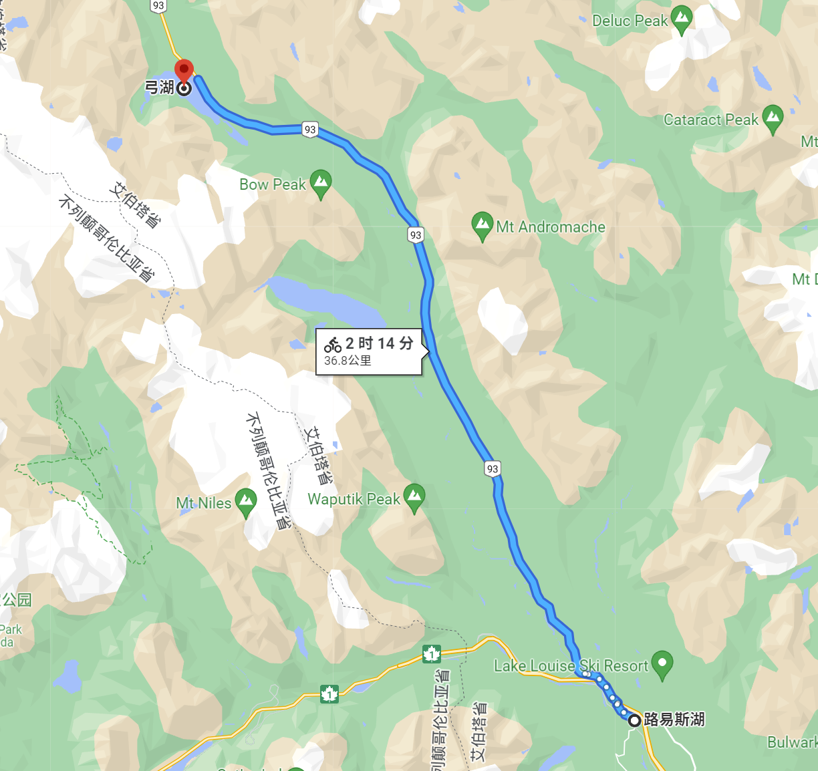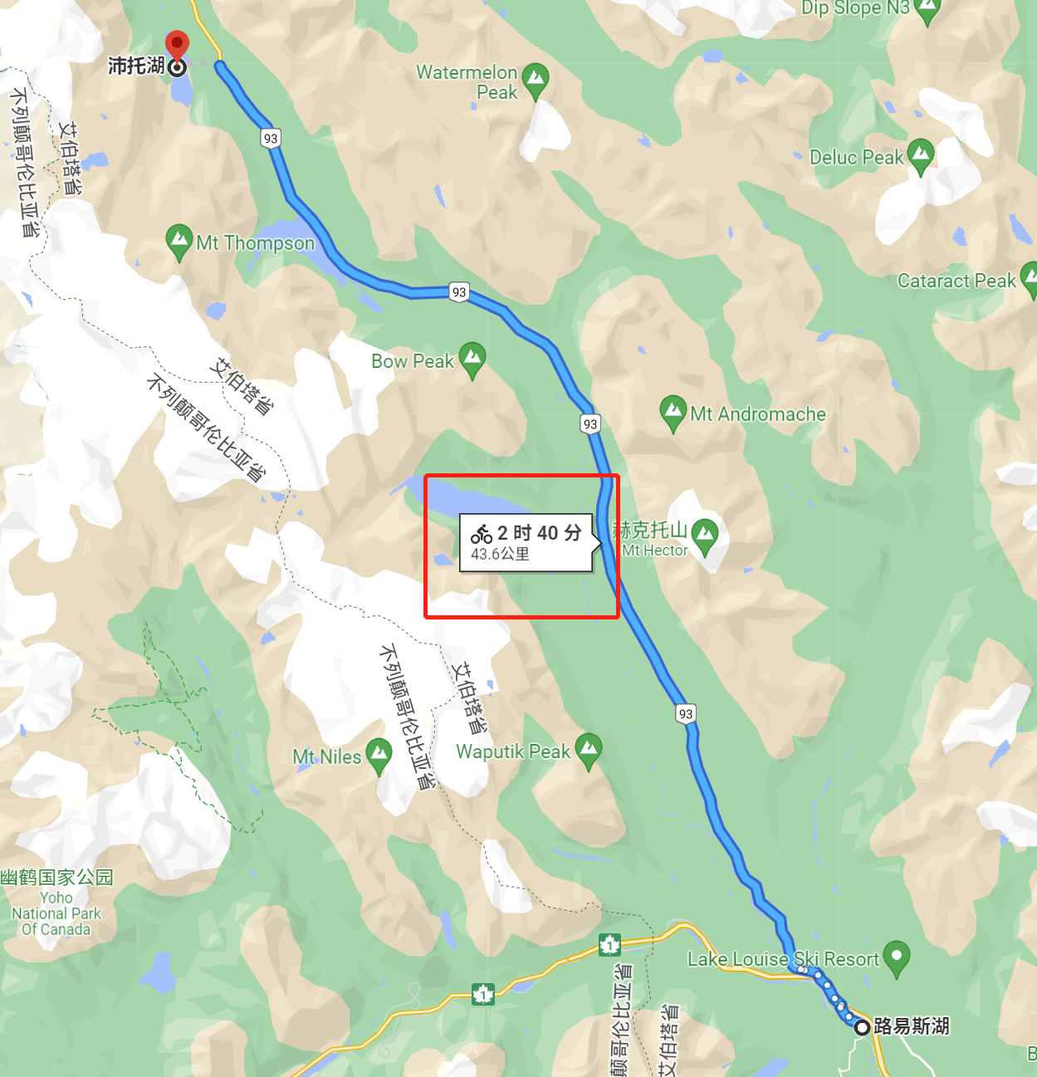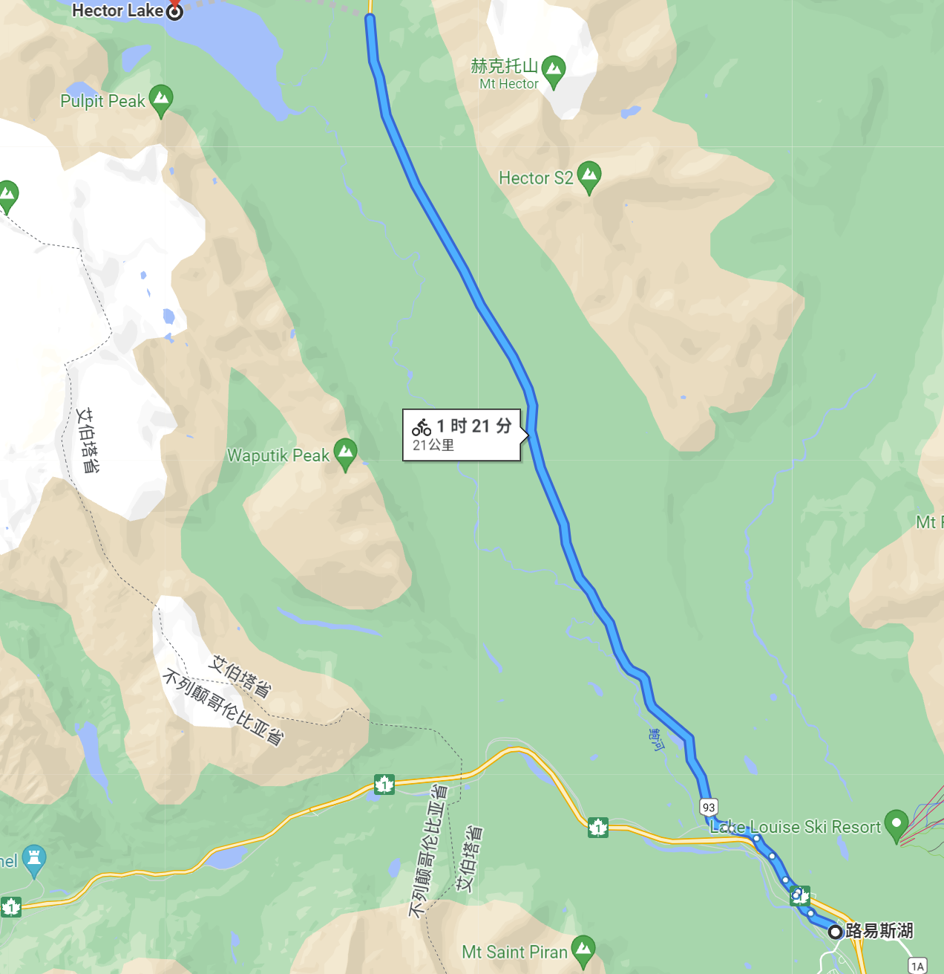

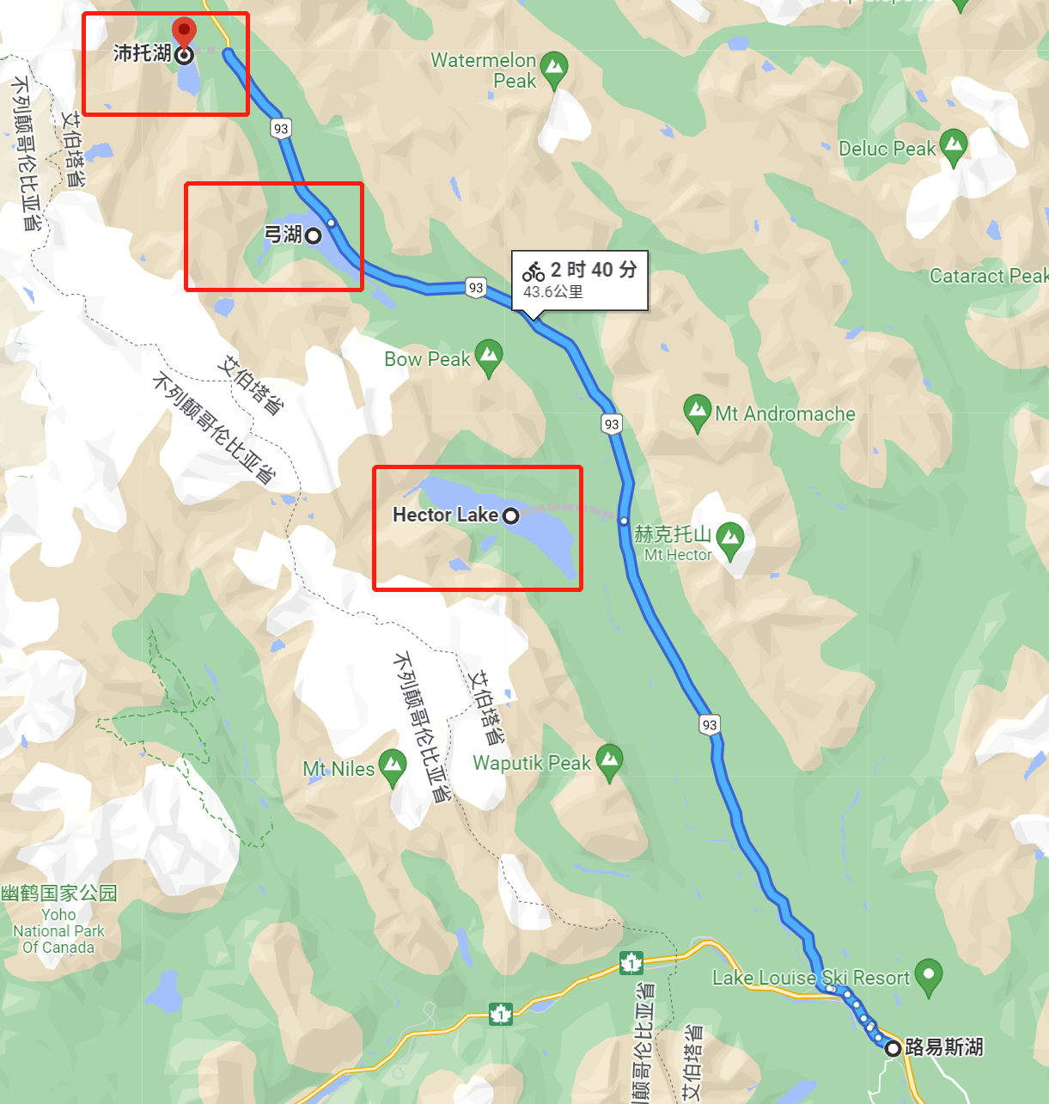 **21km到达Hector Lake、36km到达Bow lake（弓湖） ， 43km到达**Peyto Lake（佩托湖）

**路易斯湖出发的Big Beehive Trial**

**先到茶屋(Agnes Tea House)—绕到Agnes湖后边，再上到Big Beehive**

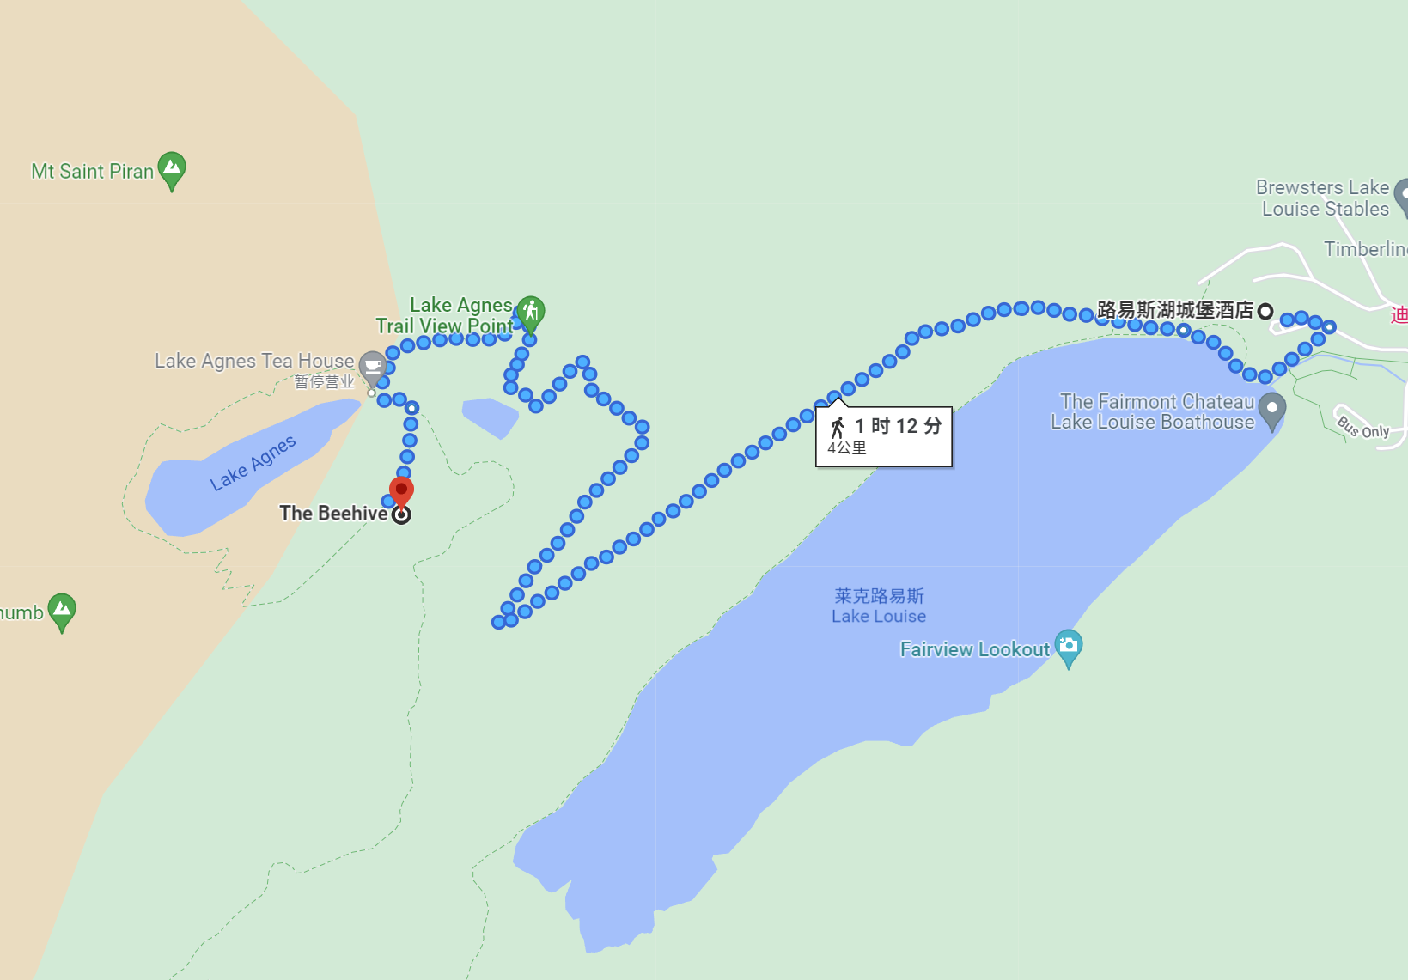

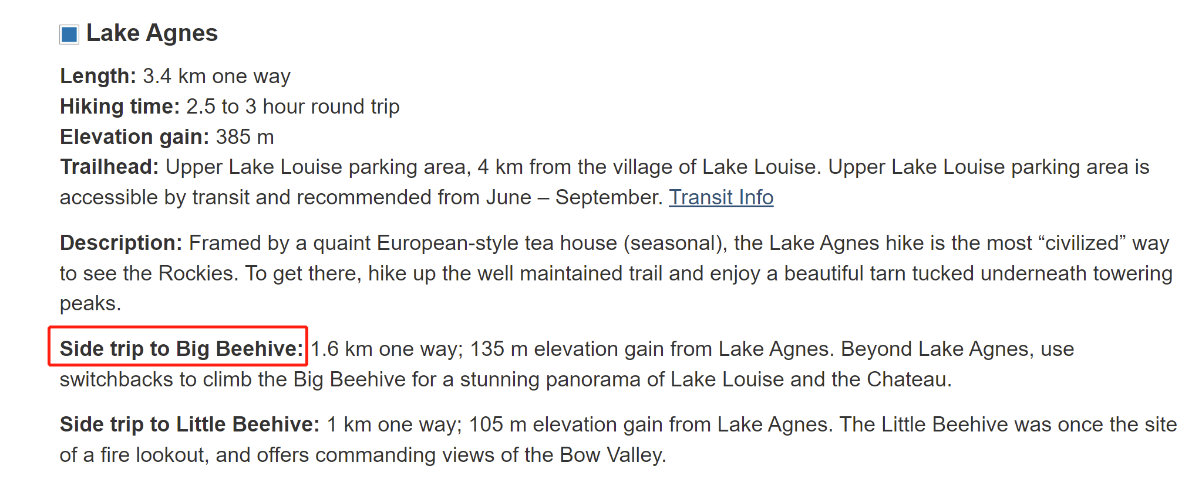

Banff出发： 班夫——明尼万卡湖 22.7KM 班夫—Two Jack Lake 11.1KM

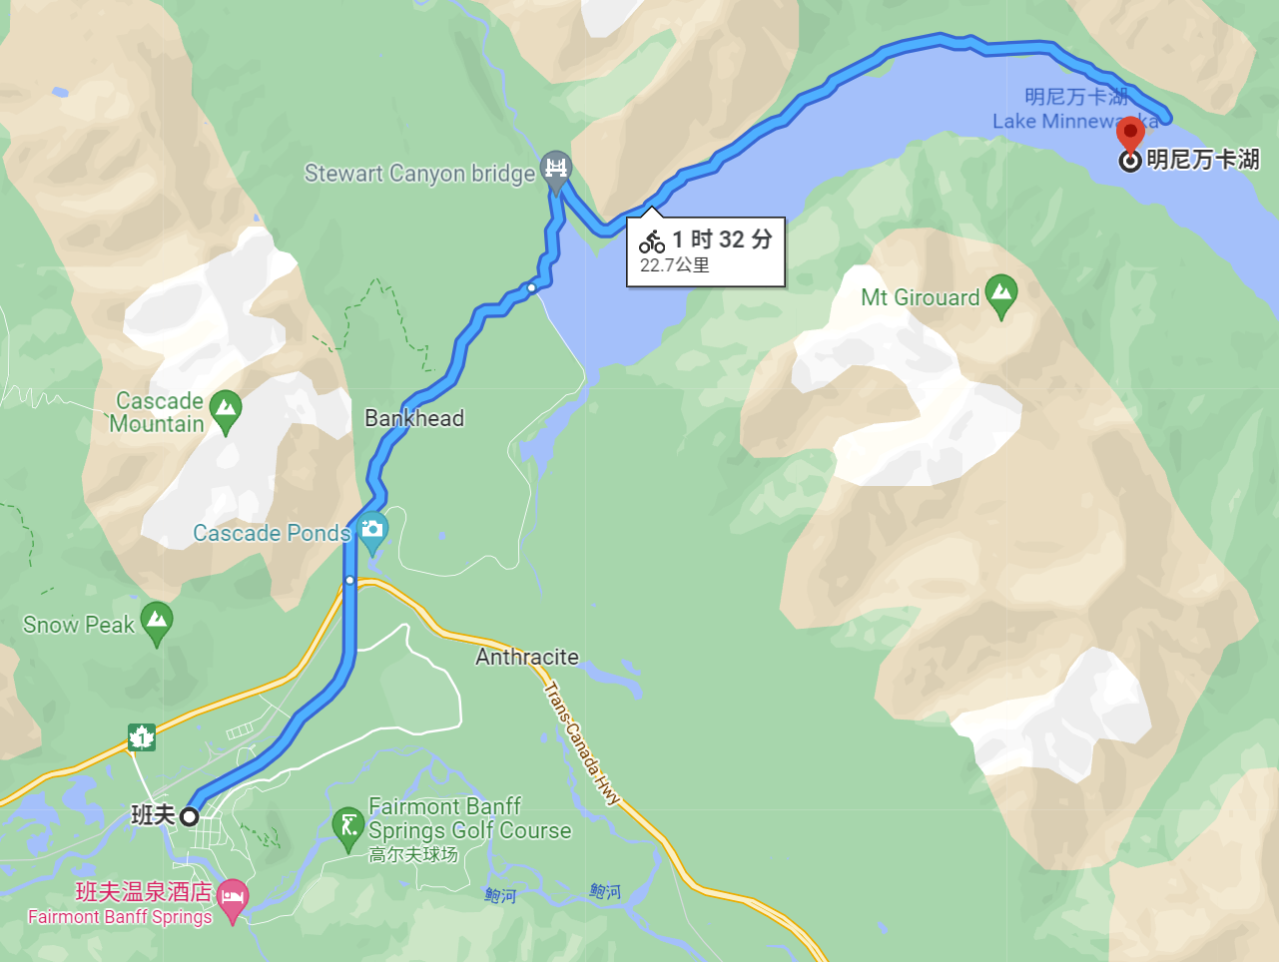 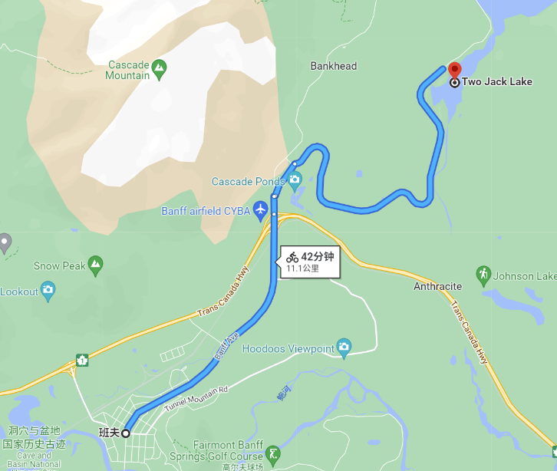

顺路 距离约翰逊湖(Johnson Lake)也不远

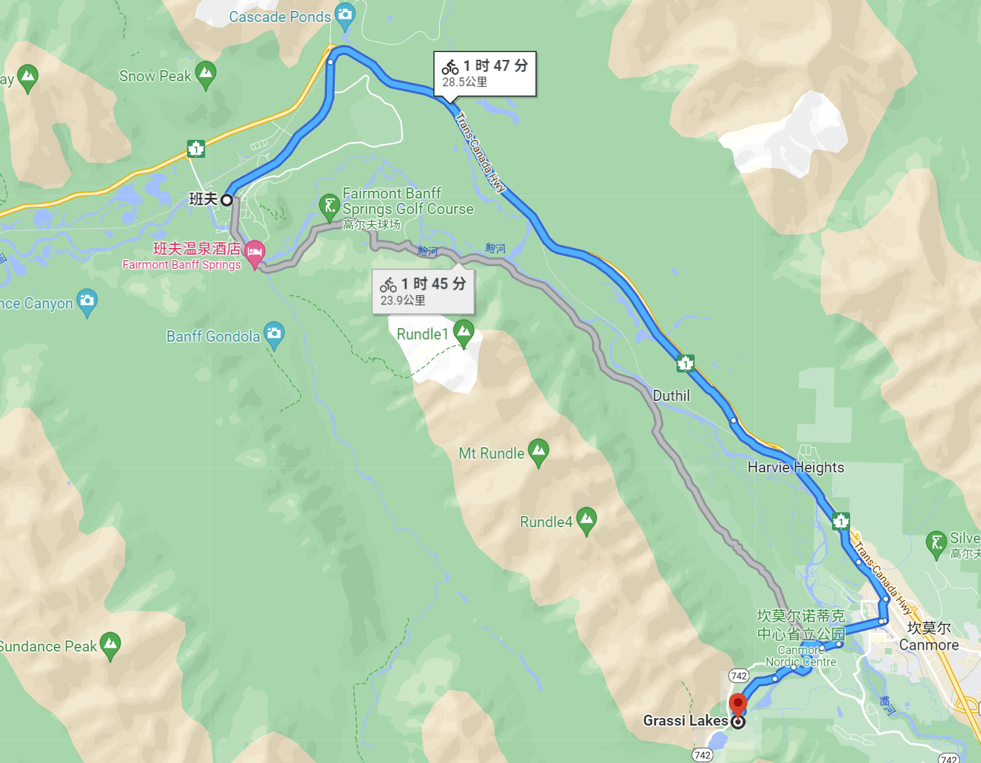

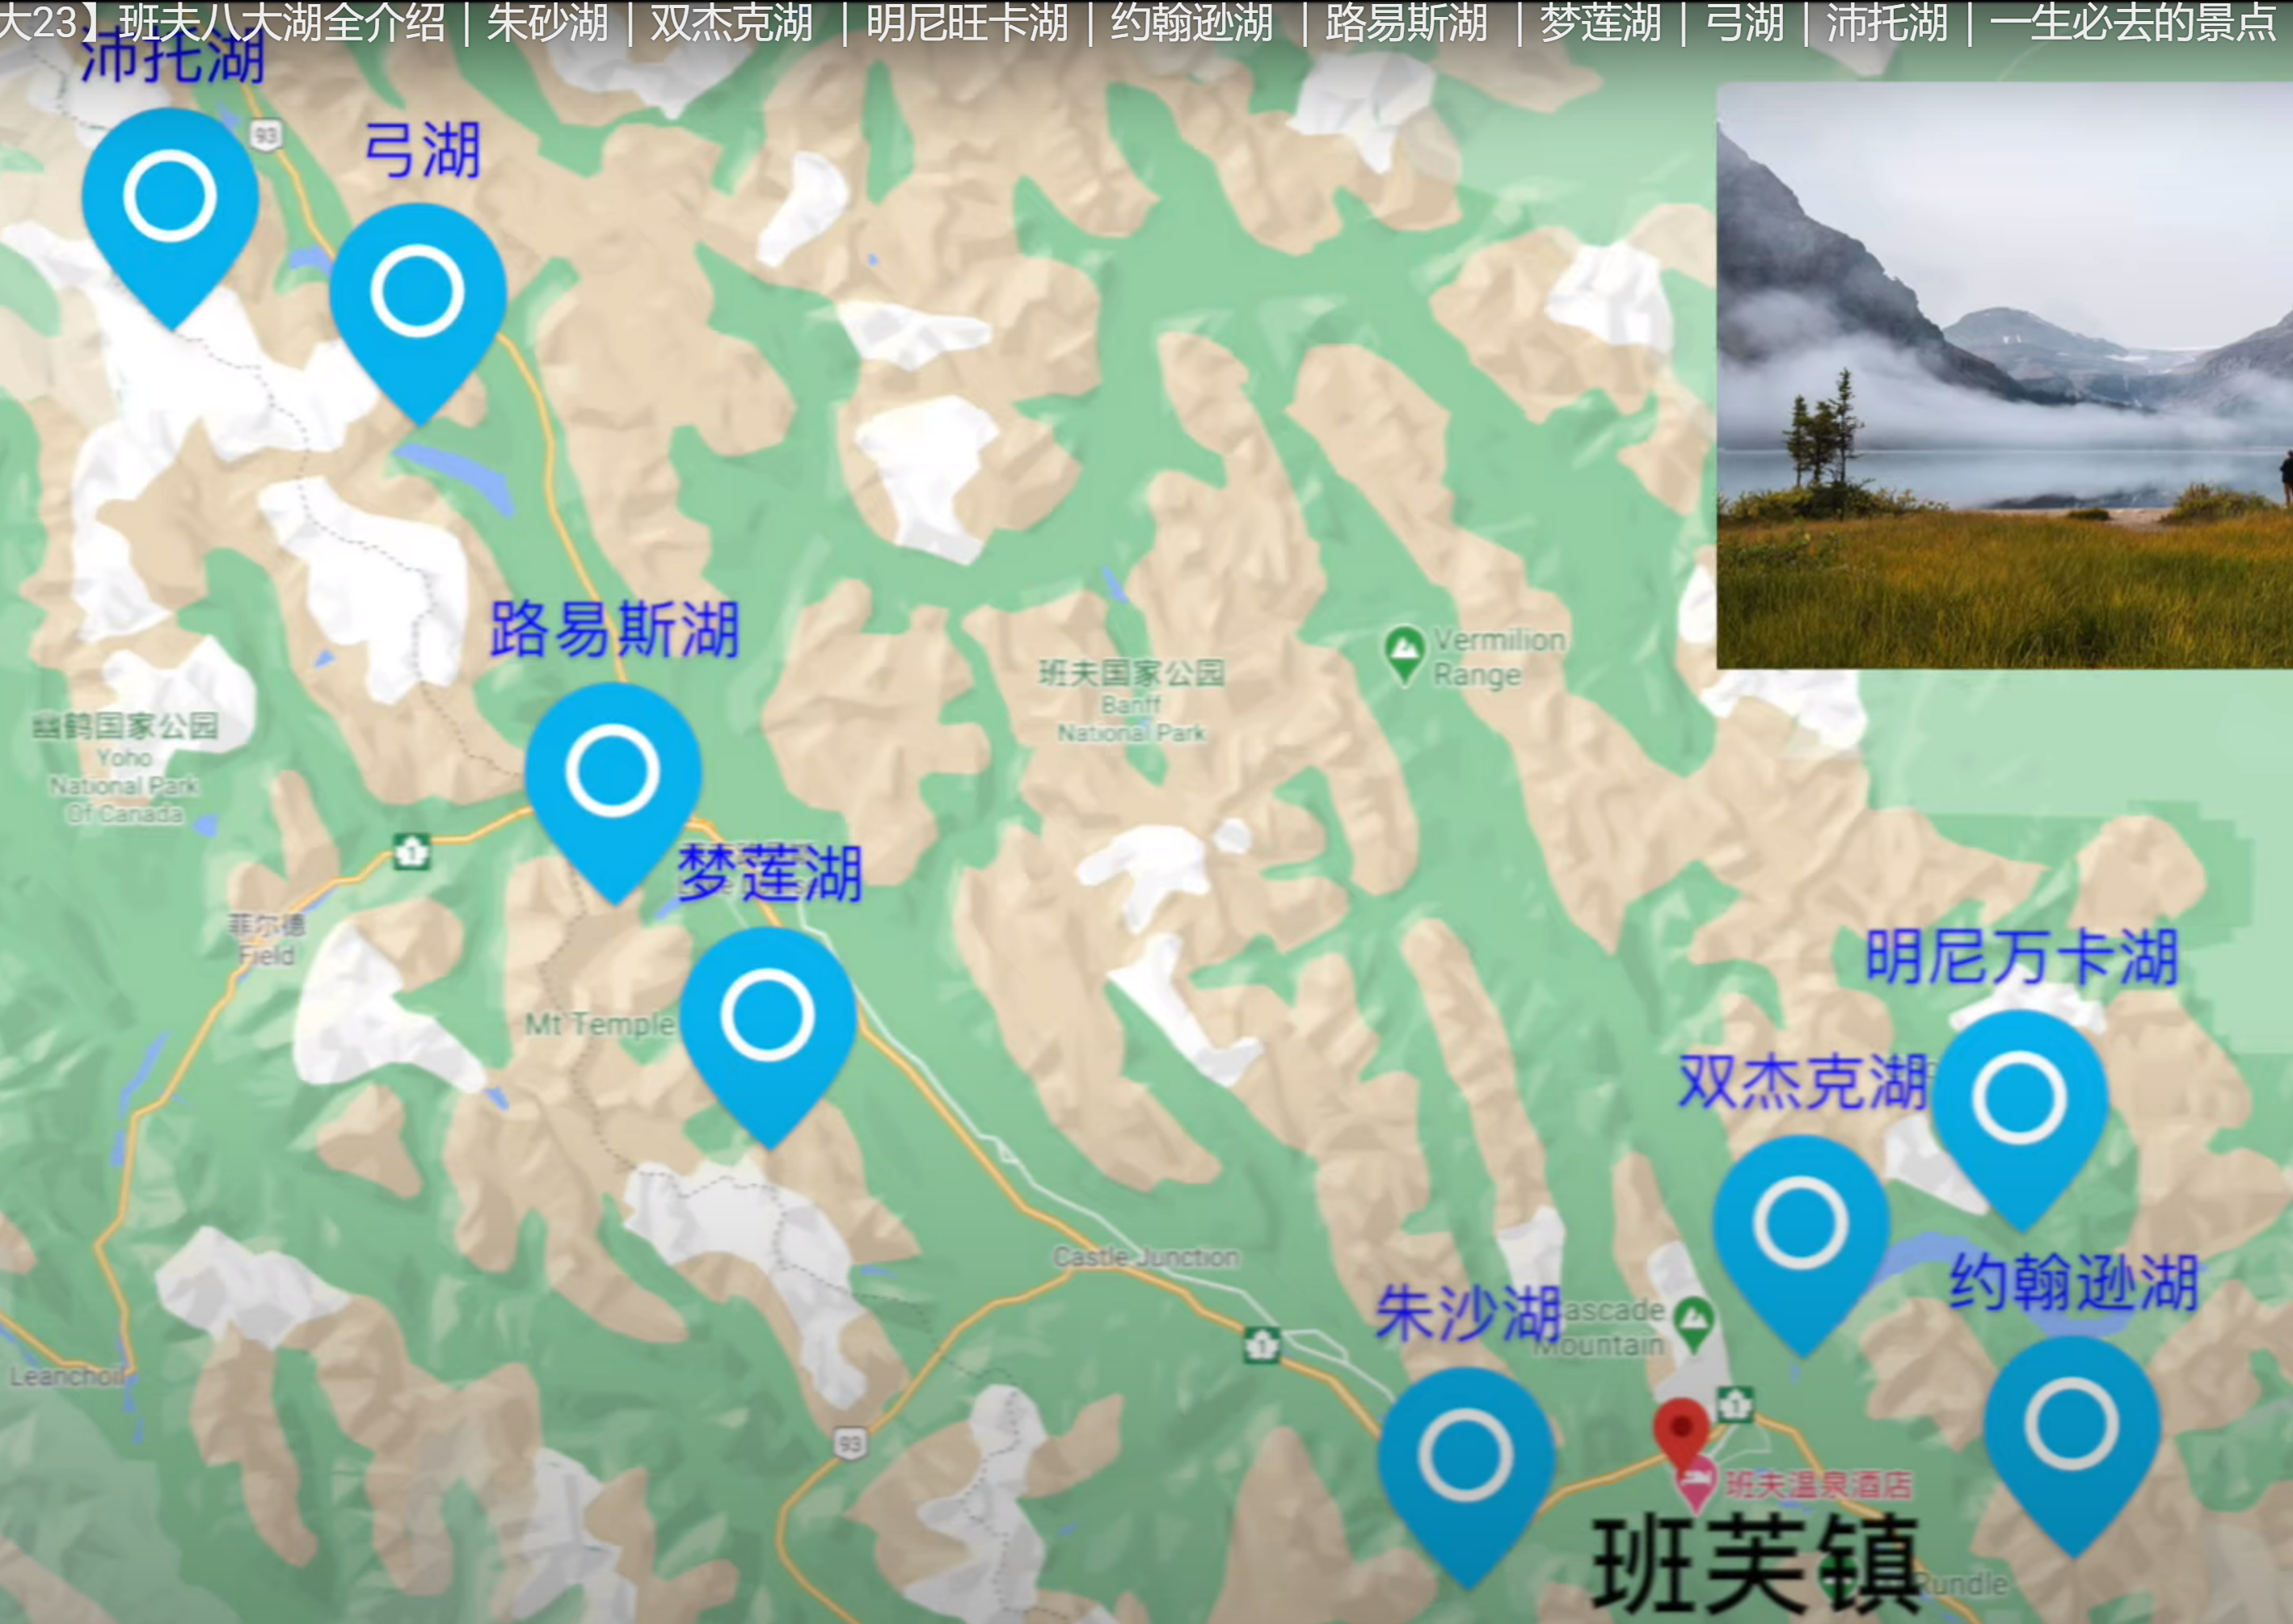

去Moraine Lake 一定要花半小时去爬上湖边那个小山头，有专卖的小路上去， 很短，半小时往返

